**Lab9 – Understanding Features of Managed Disks - Azure**

### Managed disks

Managed Disks handles the storage account creation/management in the background for you, and ensures that you do not have to worry about the scalability limits of the storage account. You simply specify the disk size and the performance tier (Standard/Premium), and Azure creates and manages the disk for you. As you add disks or scale the VM up and down, you don't have to worry about the storage being used.

Azure Managed Disks simplifies disk management for Azure IaaS VMs by managing the storage accounts associated with the VM disks. You only have to specify the type (Standard HDD, Standard SSD, or Premium SSD) and the size of disk you need, and Azure creates and manages the disk for you.

**Benefits of managed disks**

Let's take a look at some of the benefits you gain by using managed disks, starting with this Channel 9 video, Better Azure VM Resiliency with Managed Disks.

**Simple and scalable VM deployment**

Managed Disks handles storage for you behind the scenes. Previously, you had to create storage accounts to hold the disks (VHD files) for your Azure VMs. When scaling up, you had to make sure you created additional storage accounts so you didn't exceed the IOPS limit for storage with any of your disks. With Managed Disks handling storage, you are no longer limited by the storage account limits (such as 20,000 IOPS / account). You also no longer have to copy your custom images (VHD files) to multiple storage accounts. You can manage them in a central location – one storage account per Azure region – and use them to create hundreds of VMs in a subscription.

Managed Disks will allow you to create up to 50,000 VM disks of a type in a subscription per region, which will enable you to create thousands of VMs in a single subscription. This feature also further increases the scalability of Virtual Machine Scale Sets by allowing you to create up to a thousand VMs in a virtual machine scale set using a Marketplace image.

**Better reliability for Availability Sets**

Managed Disks provides better reliability for Availability Sets by ensuring that the disks of VMs in an Availability Set are sufficiently isolated from each other to avoid single points of failure. Disks are automatically placed in different storage scale units (stamps). If a stamp fails due to hardware or software failure, only the VM instances with disks on those stamps fail. For example, let's say you have an application running on five VMs, and the VMs are in an Availability Set. The disks for those VMs won't all be stored in the same stamp, so if one stamp goes down, the other instances of the application continue to run.

**Highly durable and available**

Azure Disks are designed for 99.999% availability. Rest easier knowing that you have three replicas of your data that enables high durability. If one or even two replicas experience issues, the remaining replicas help ensure persistence of your data and high tolerance against failures. This architecture has helped Azure consistently deliver enterprise-grade durability for IaaS disks, with an industry-leading ZERO% Annualized Failure Rate.

**Granular access control**

You can use Azure Role-Based Access Control (RBAC) to assign specific permissions for a managed disk to one or more users. Managed Disks exposes a variety of operations, including read, write (create/update), delete, and retrieving a shared access signature (SAS) URI for the disk. You can grant access to only the operations a person needs to perform their job. For example, if you don't want a person to copy a managed disk to a storage account, you can choose not to grant access to the export action for that managed disk. Similarly, if you don't want a person to use an SAS URI to copy a managed disk, you can choose not to grant that permission to the managed disk.

**Azure Backup service support**

Use Azure Backup service with Managed Disks to create a backup job with time-based backups, easy VM restoration, and backup retention policies. Managed Disks only support Locally Redundant Storage (LRS) as the replication option. Three copies of the data are kept within a single region. For regional disaster recovery, you must back up your VM disks in a different region using Azure Backup service and a GRS storage account as backup vault. Currently Azure Backup supports the disk sizes up to 4TB disks. You need to upgrade VM backup stack to V2 for support of 4TB disks. For more information, see Using Azure Backup service for VMs with Managed Disks.

**Pricing and Billing**

When using Managed Disks, the following billing considerations apply:

Storage Type

Disk Size

Number of transactions

Outbound data transfers

Managed Disk Snapshots (full disk copy)

Let's take a closer look at these options.

**Storage Type:** Managed Disks offers 3 performance tiers: Standard HDD, Standard SSD, and Premium. The billing of a managed disk depends on which type of storage you have selected for the disk.

**Disk Size:** Billing for managed disks depends on the provisioned size of the disk. Azure maps the provisioned size (rounded up) to the nearest Managed Disks option as specified in the tables below. Each managed disk maps to one of the supported provisioned sizes and is billed accordingly. For example, if you create a standard managed disk and specify a provisioned size of 200 GB, you are billed as per the pricing of the S15 Disk type.

**Number of transactions:** You are billed for the number of transactions that you perform on a standard managed disk.

Standard SSD Disks use IO Unit size of 256KB. If the data being transferred is less than 256 KB, it is considered 1 I/O unit. Larger I/O sizes are counted as multiple I/Os of size 256 KB. For example, a 1,100 KB I/O is counted as five I/O units.

There is no cost for transactions for a premium managed disk.

**Outbound data transfers:** Outbound data transfers (data going out of Azure data centers) incur billing for bandwidth usage.

For detailed information on pricing for Managed Disks, see Managed Disks Pricing.

**Topology**

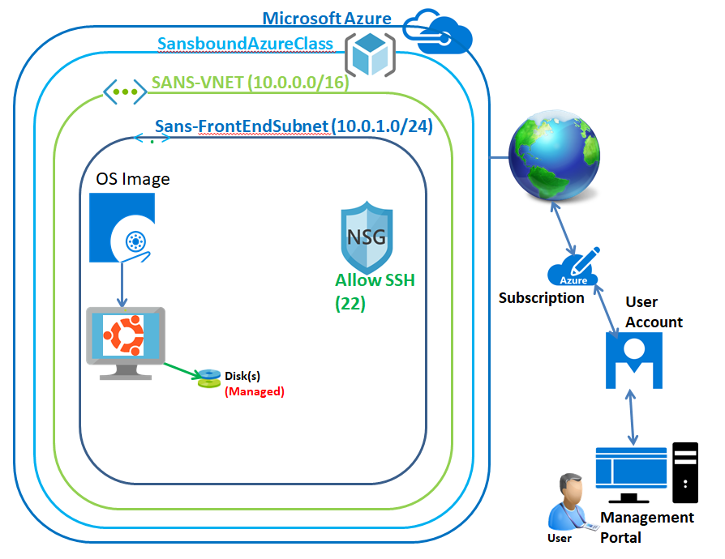

In Azure portal, click on **“Resource groups”** in left side panel.

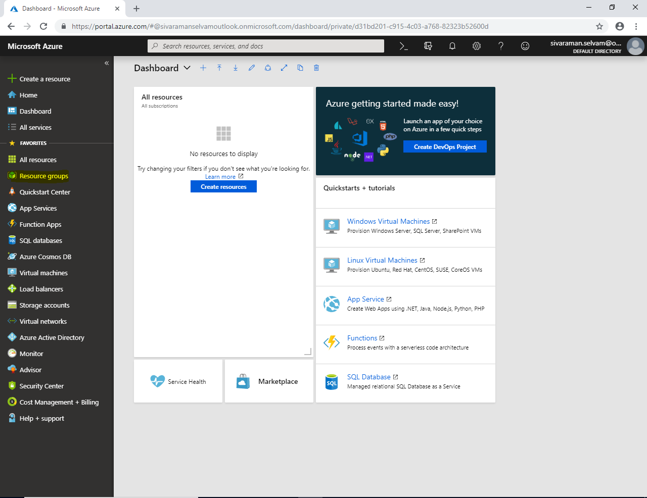

In **“Resource groups”** click **“Add”** to add new resource group.

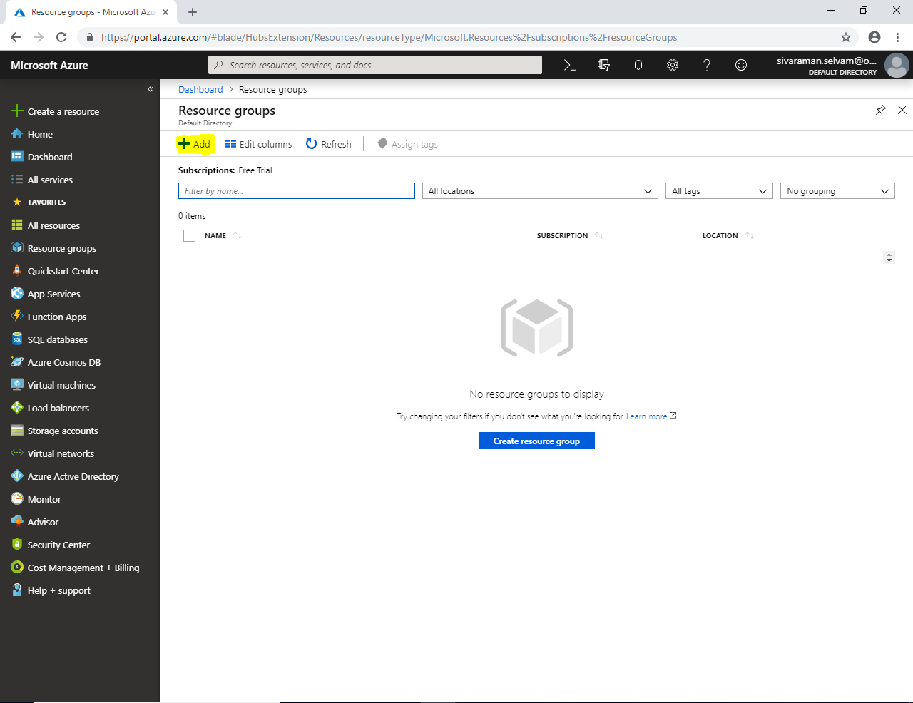

While creating **“Resource group”** type **“Resource Group Name”** as **“SansboundAzureClass”**, select **“Subscription”** as **“Free Trial”** and select **“Resource group location”** you have required to place the Resource group.

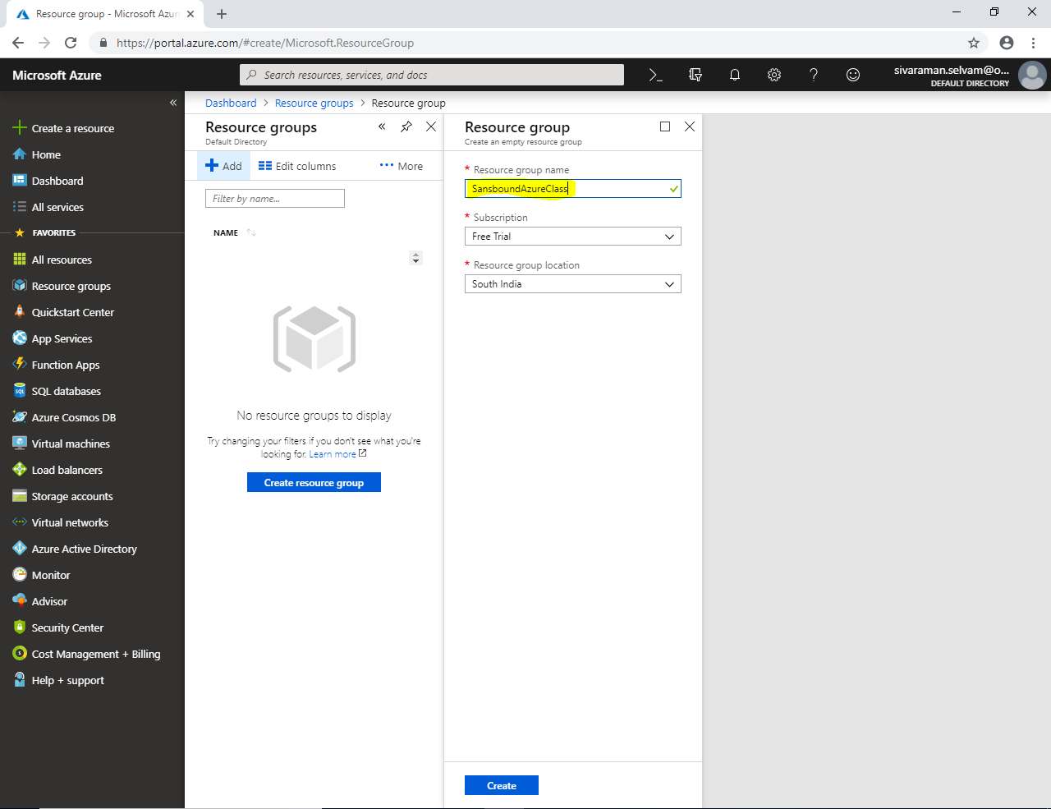

Click **”Create”**.

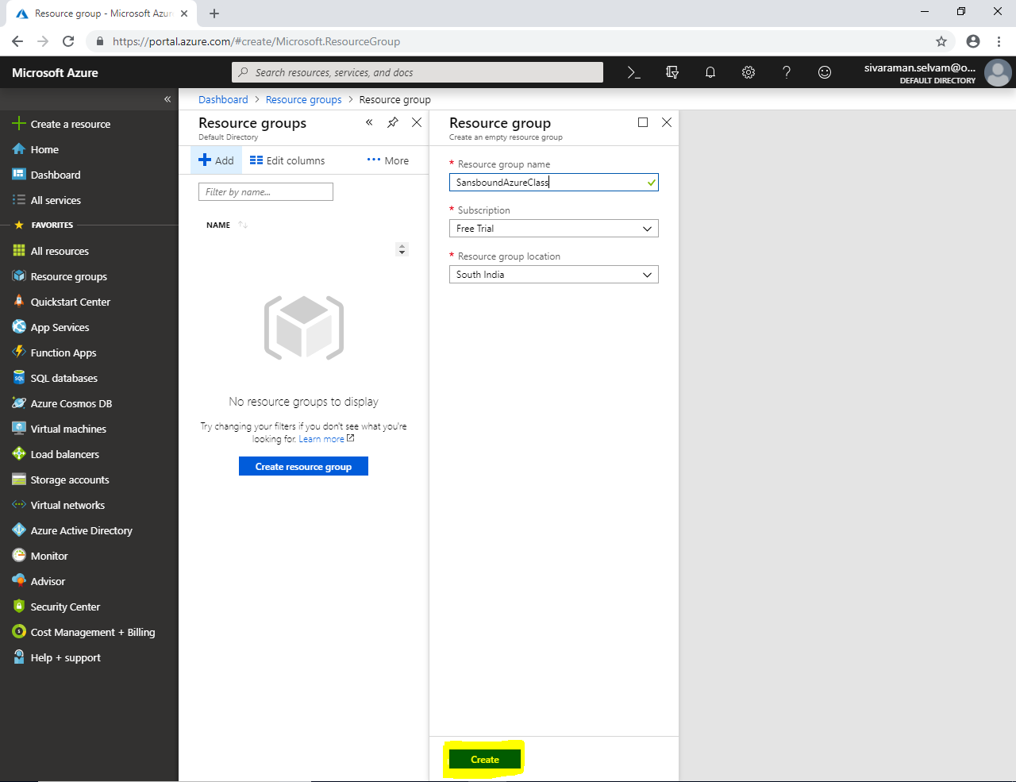

Click on **“Virtual networks”** in left side panel.

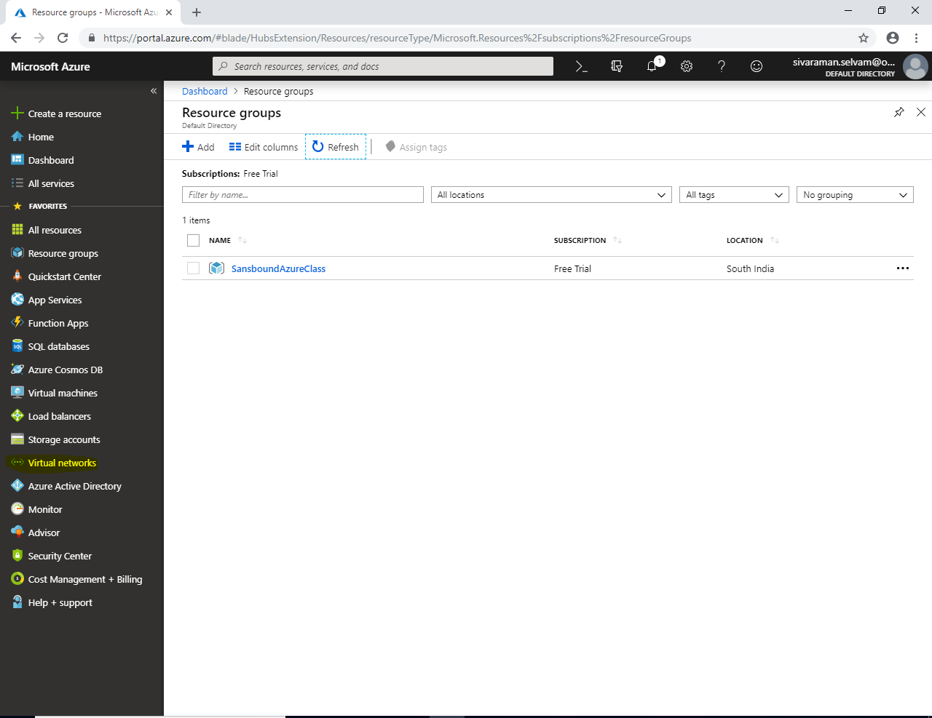

In **“Virtual networks”** click **“Add”**.

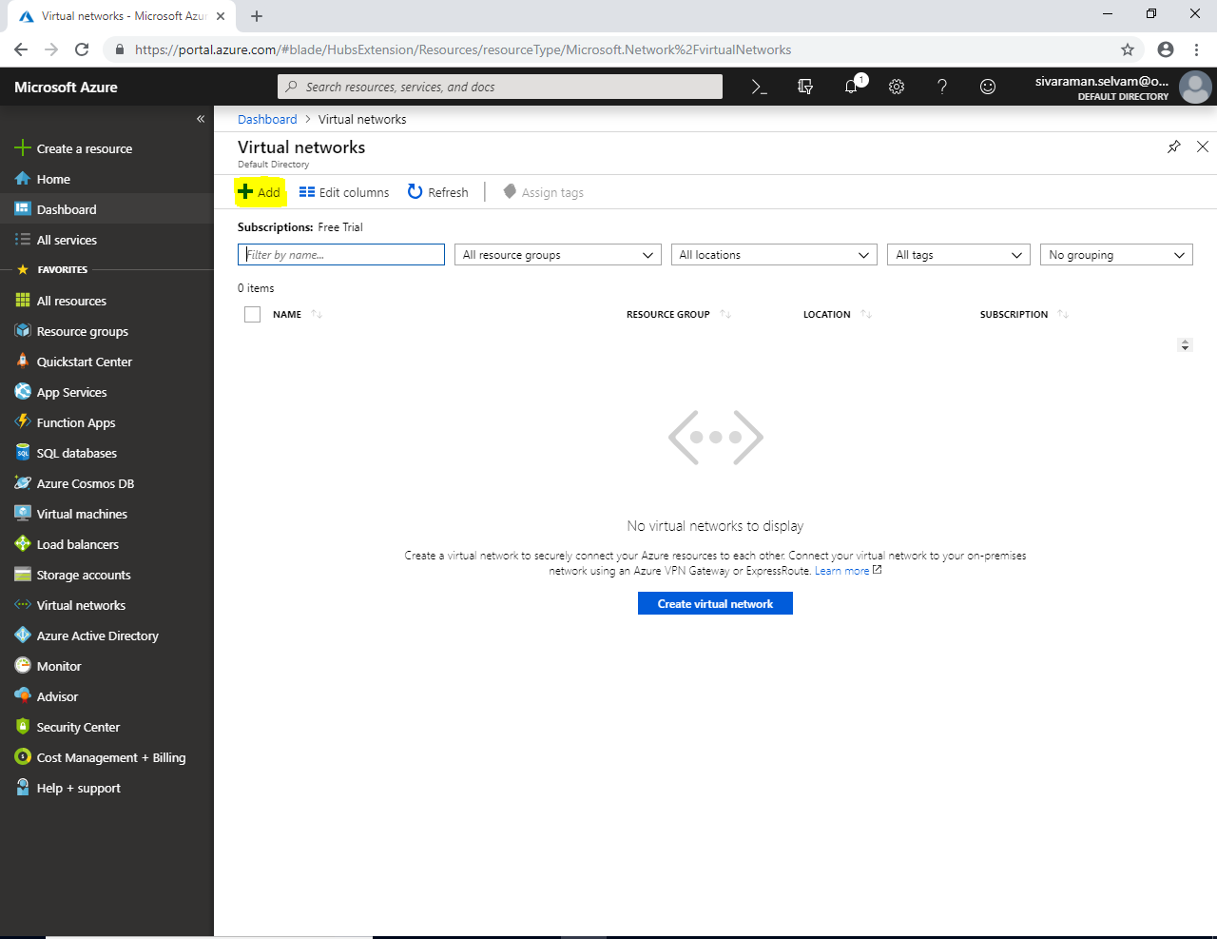

While creating network,

Type **“Virtual network”** name as **“SANS-VNET”**.

Specify **“Address range”** as **10.0.0.0/16**

Subscription as **“Free Trial”**.

Select **“Resource Group”** as **“SansboundAzureClass”**.

Select **“Location”** as **“South India”**.

In **“Subnet”** type **“Subnet name”** as **“Sans-FrontEndSubnet”**

In **“Address range”** for the subnet type as **10.0.1.0/24**

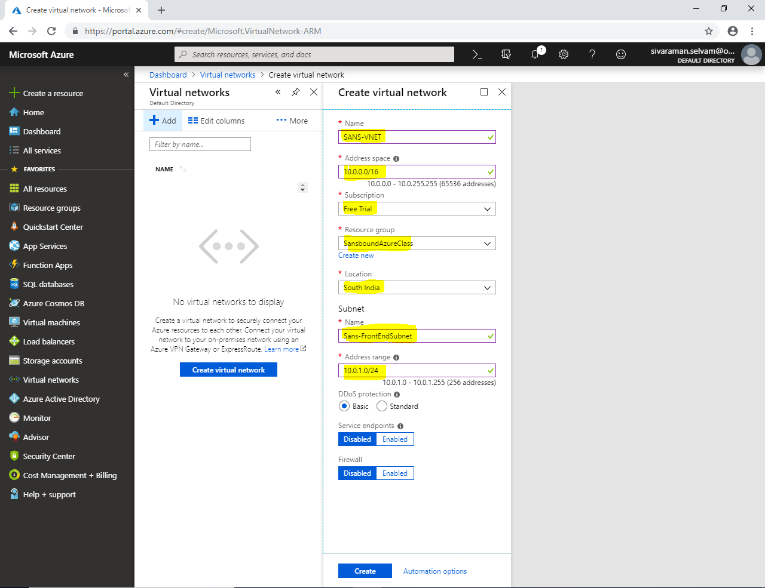

Click “**Create”**.

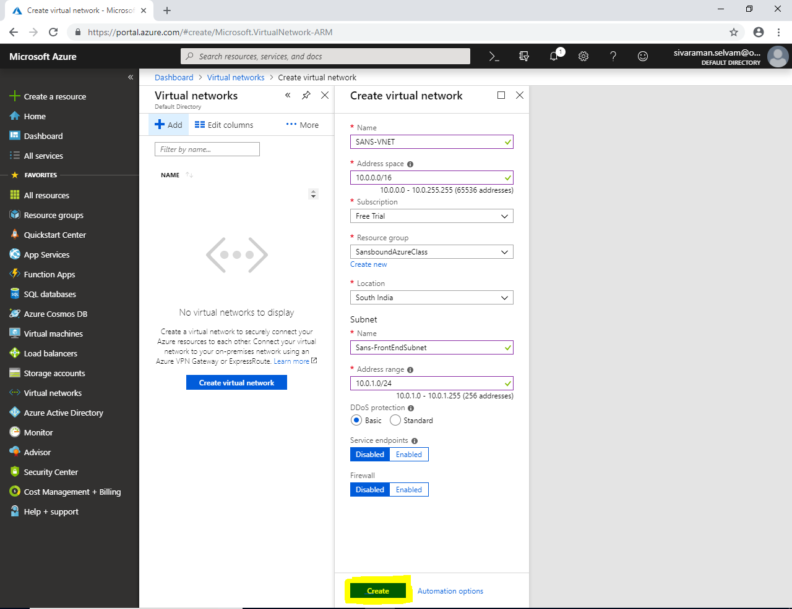

Click on **“Virtual machines”**.

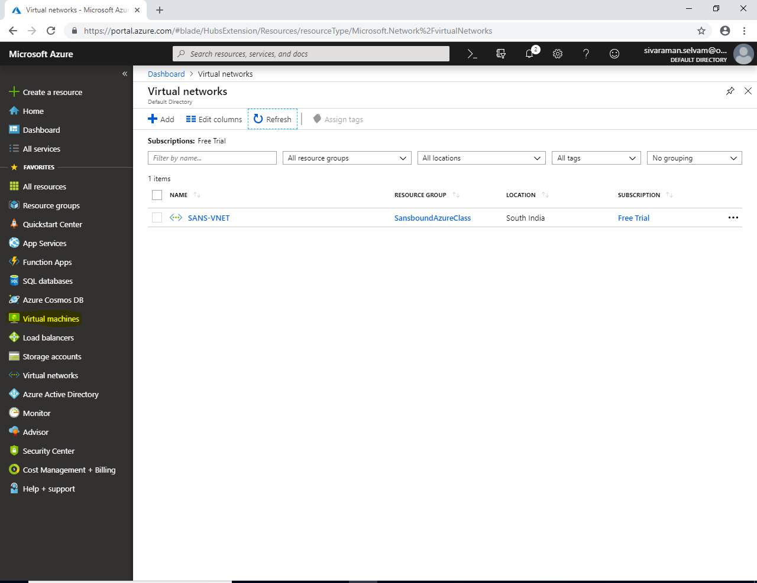

Click **“Add”**.

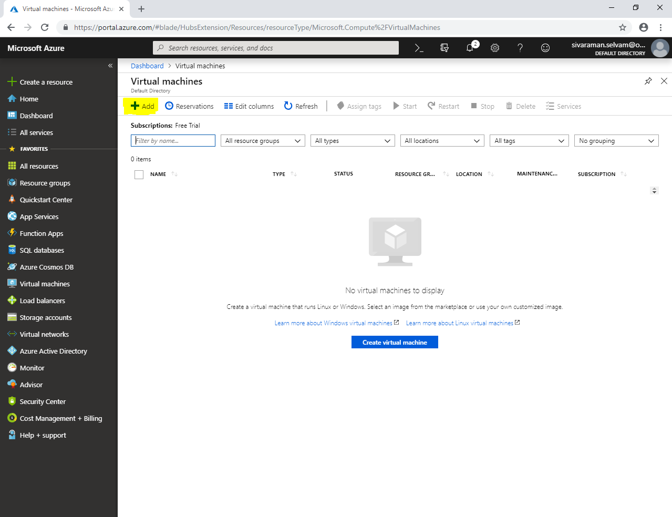

While creating **“Virtual machine”**

Select **“Subscription”** as **“Free Trial”**.

Select **“Resource Group”** as **“SansboundAzureClass”**.

Type **“Virtual machine name”** as **“UbuntuVM-Azure”**.

Select **“Region”** as **“South India”** (You can select any other region as per your wish / requirement).

Change **“VM Size”** as **“Standard B1s”**.

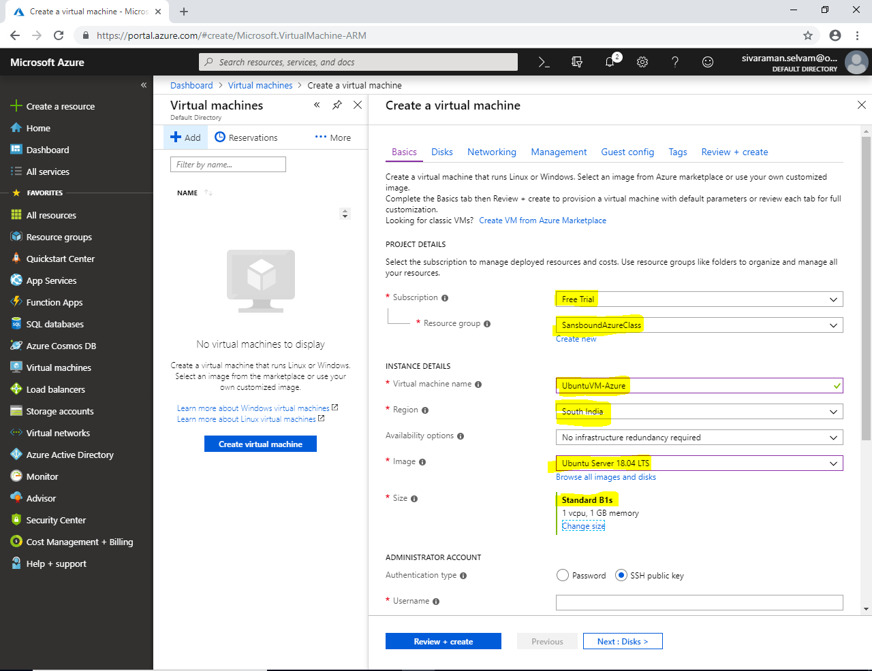

In **“Administrator Account”**, set **“Authentication type”** as **“Password”**.

Type **“Username”** as **“sansbound”**

Type **“Password”** as per your wish.

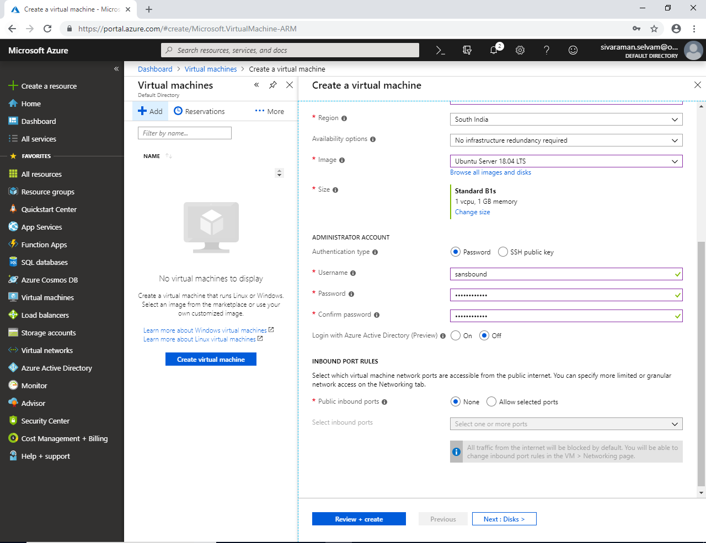

In **“Inbound Port Rules”**

**“Public inbound ports”** as **“Allow selected ports”**.

**“Select inbound ports”** as **“SSH”**.

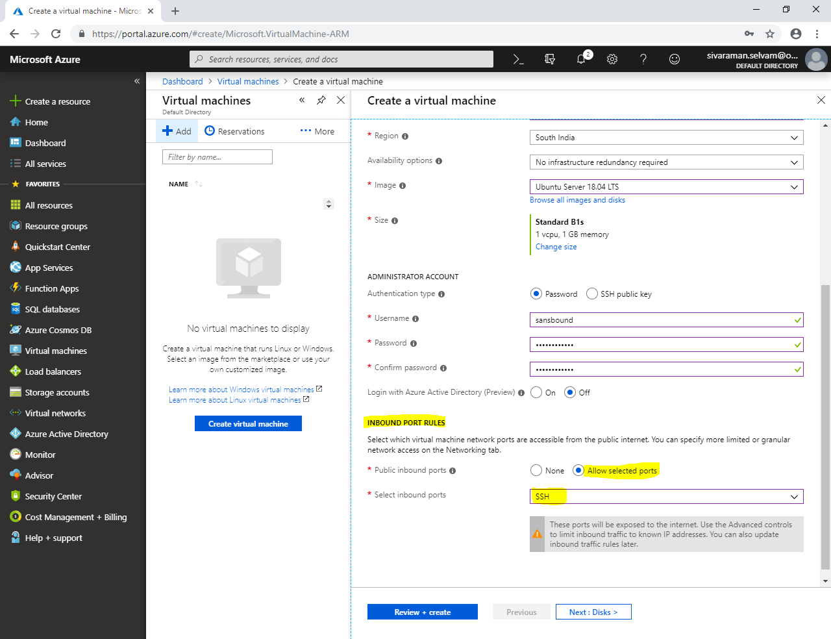

Click **“Next : Disks >”**.

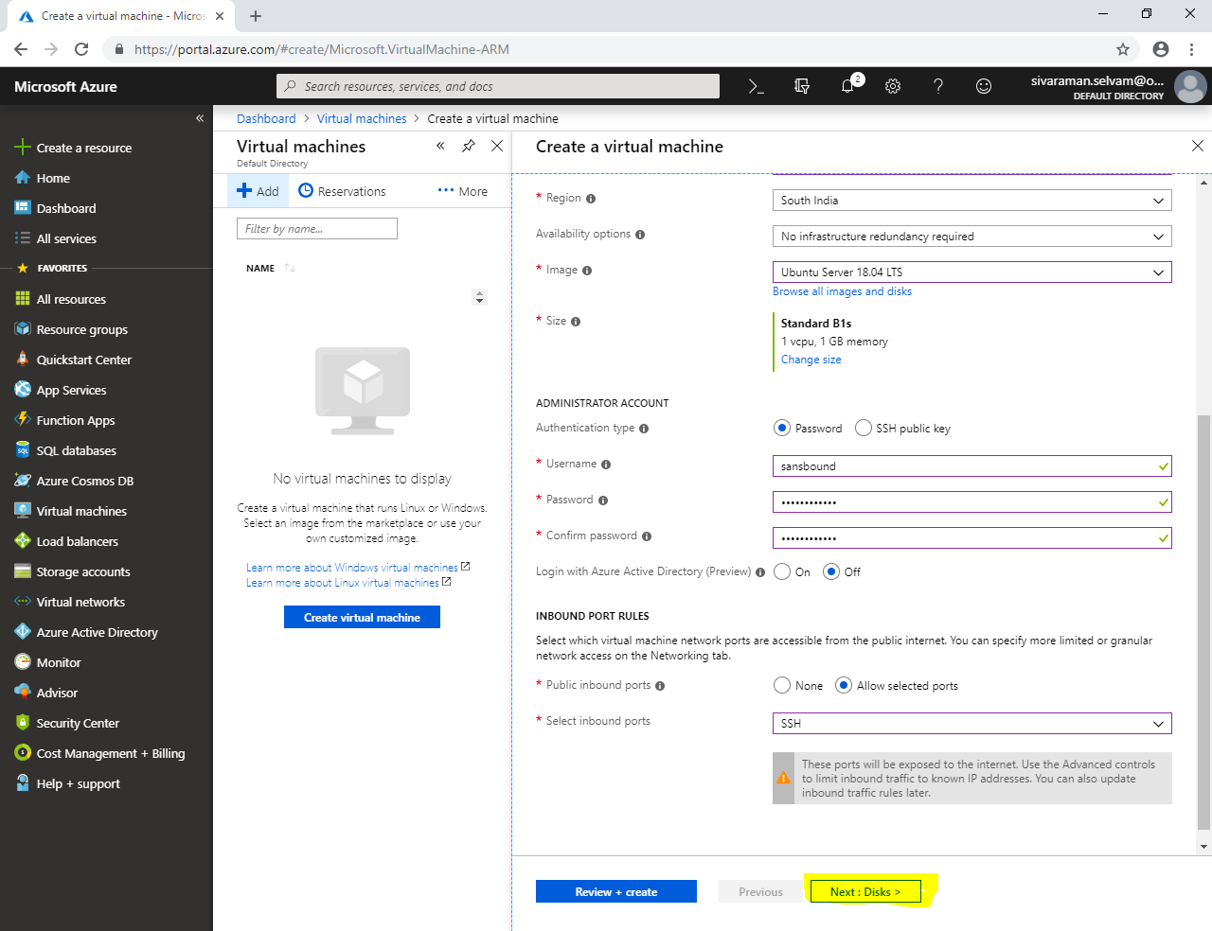

In **“Disks”**.

If you have selected **“Premium SSD”** performance and price will be high.

If you have selected **“Standard SSD”** performance and price will be lower than **“Premium SSD”**.

If you have selected **“Standard HDD”** performance and price will be lower than **“Standard SSD”**. It’s similar to magnetic hard disk.

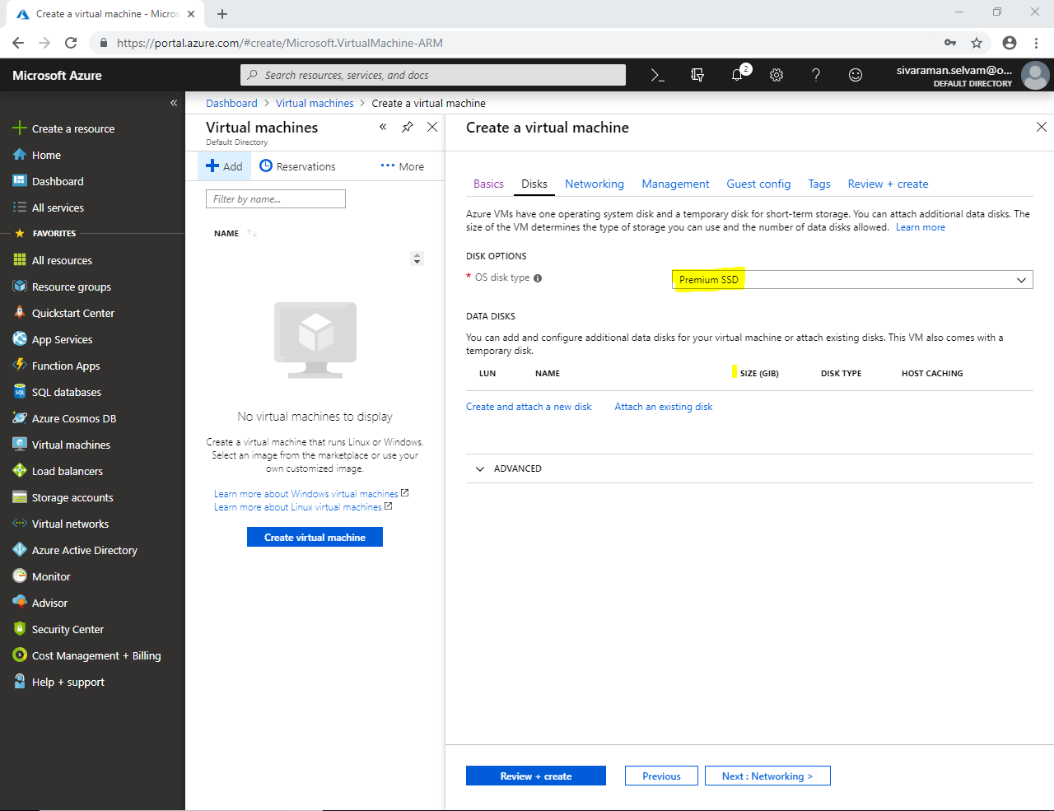

Click on **“Advanced”**.

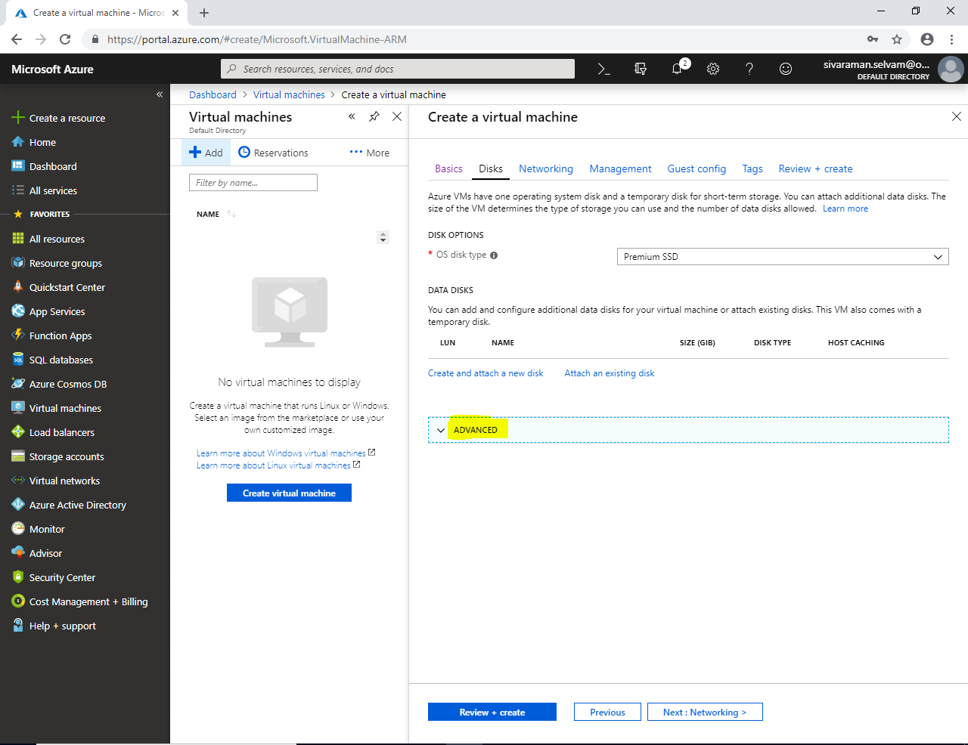

By default, while we create Virtual machines it will be created with **“Managed disks”**.

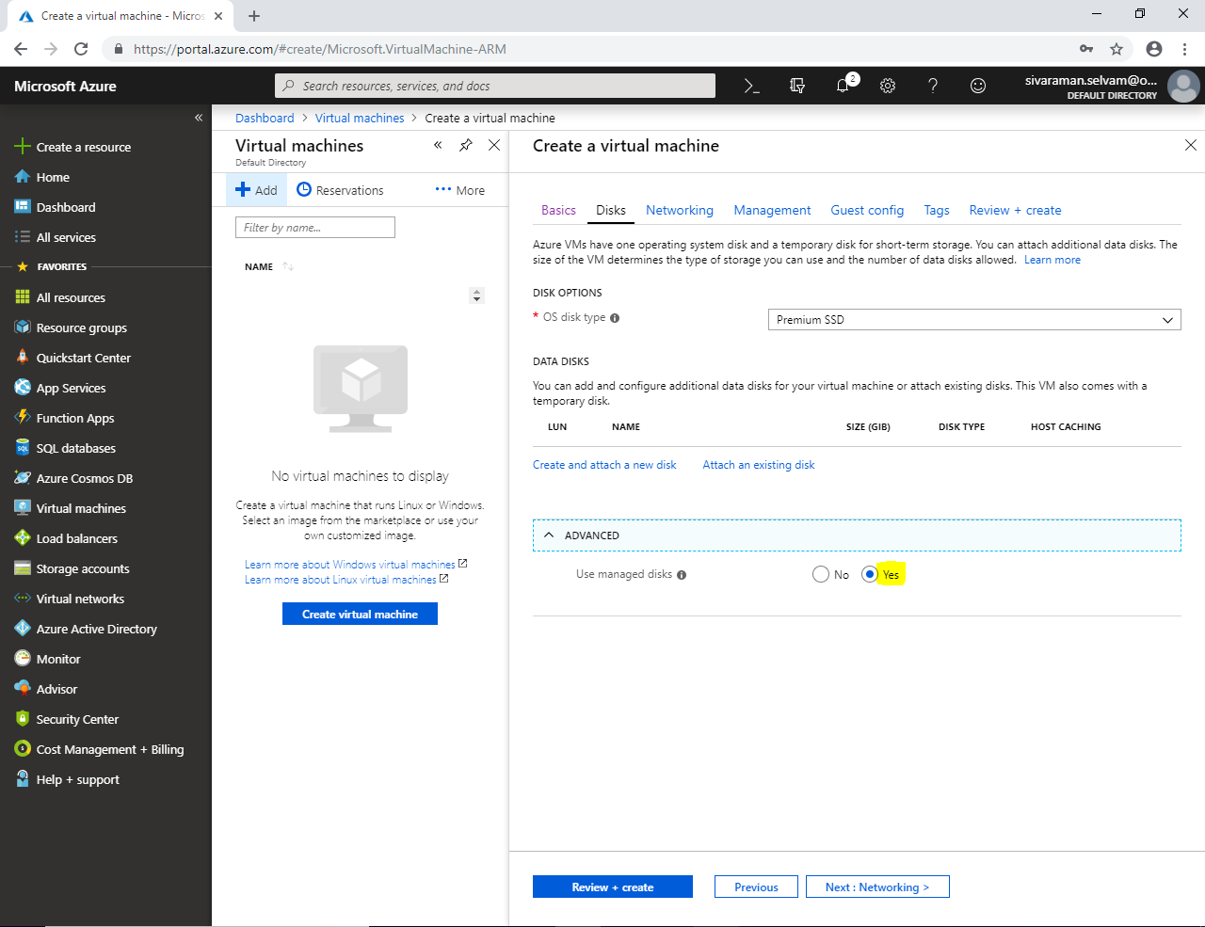

Click **“Next : Networking >”**.

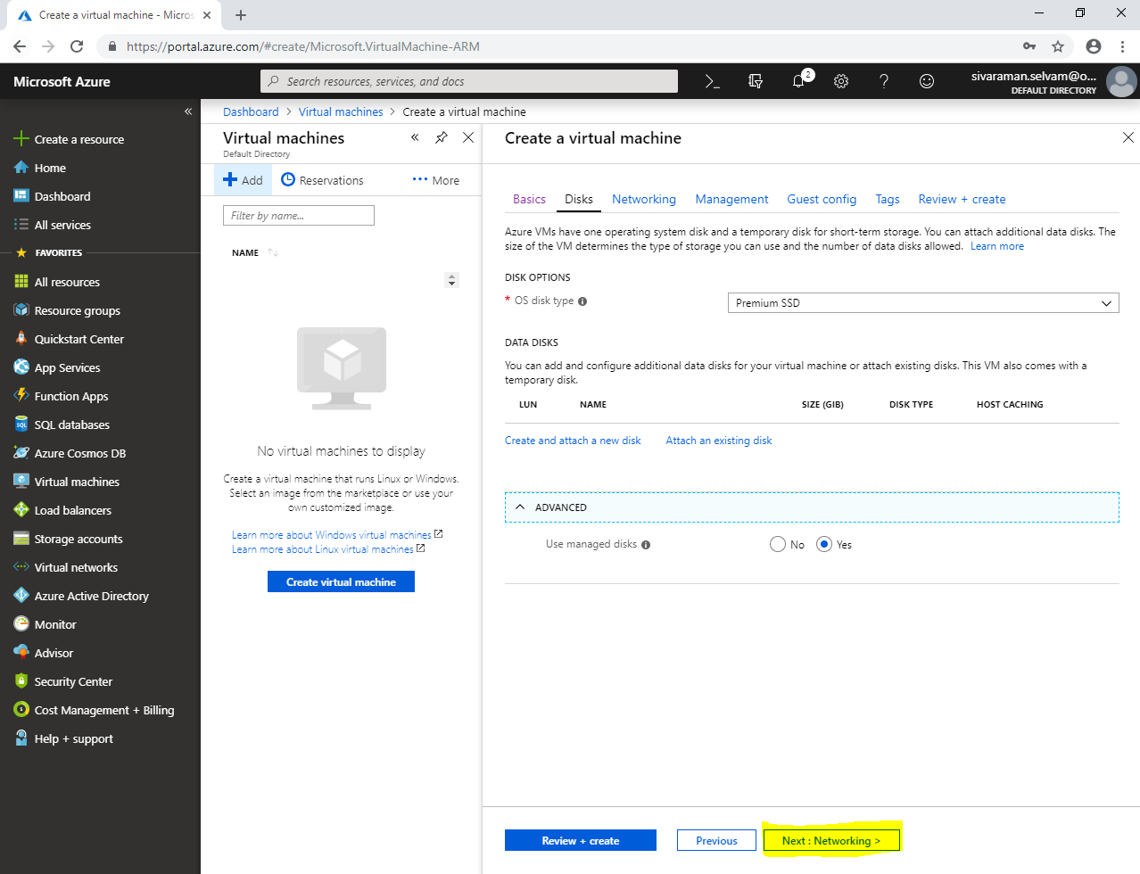

In **“Networking”**

Ensure that **“Virtual Network”** as **“SANS-VNET”**.

Ensure that **“Subnet”** as **“Sans-FrontEndSubnet”**.

Ensure that Public IP for Virtual machine.

In NIC **“Network Security Group”** as **“Basic”**.

In **“Public inbound ports”** set as **“Allow selected ports”**.

In **“Select inbound ports”** click **“SSH”**.

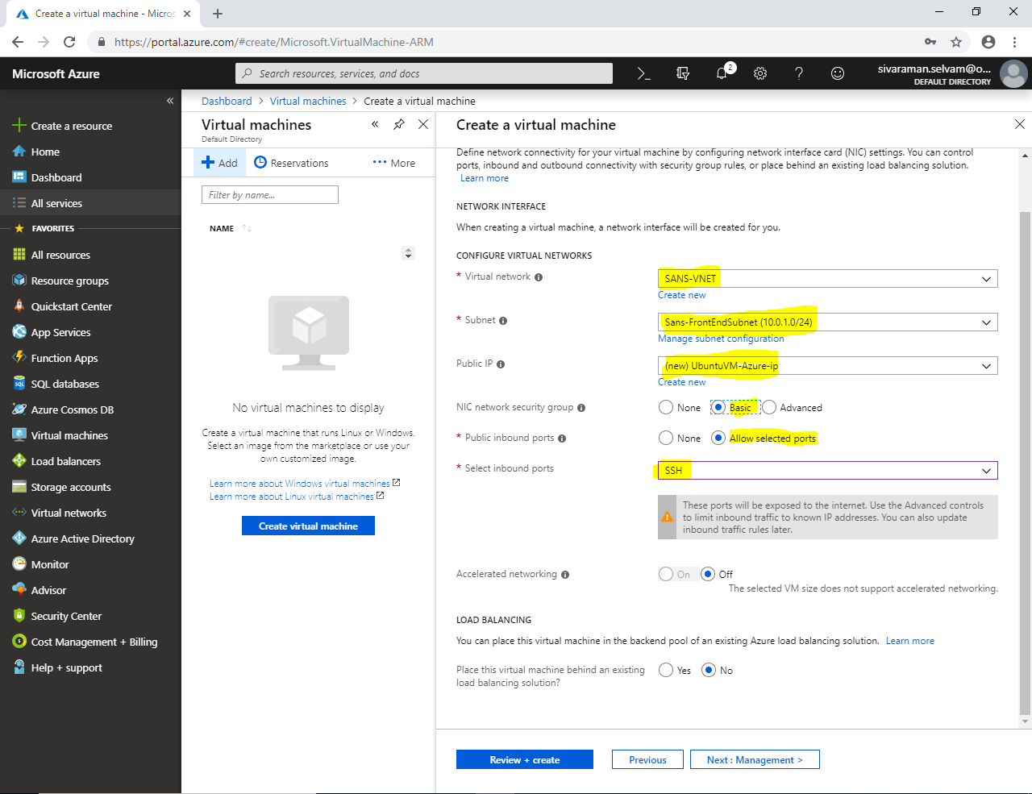

Click **“Next : Management >”**.

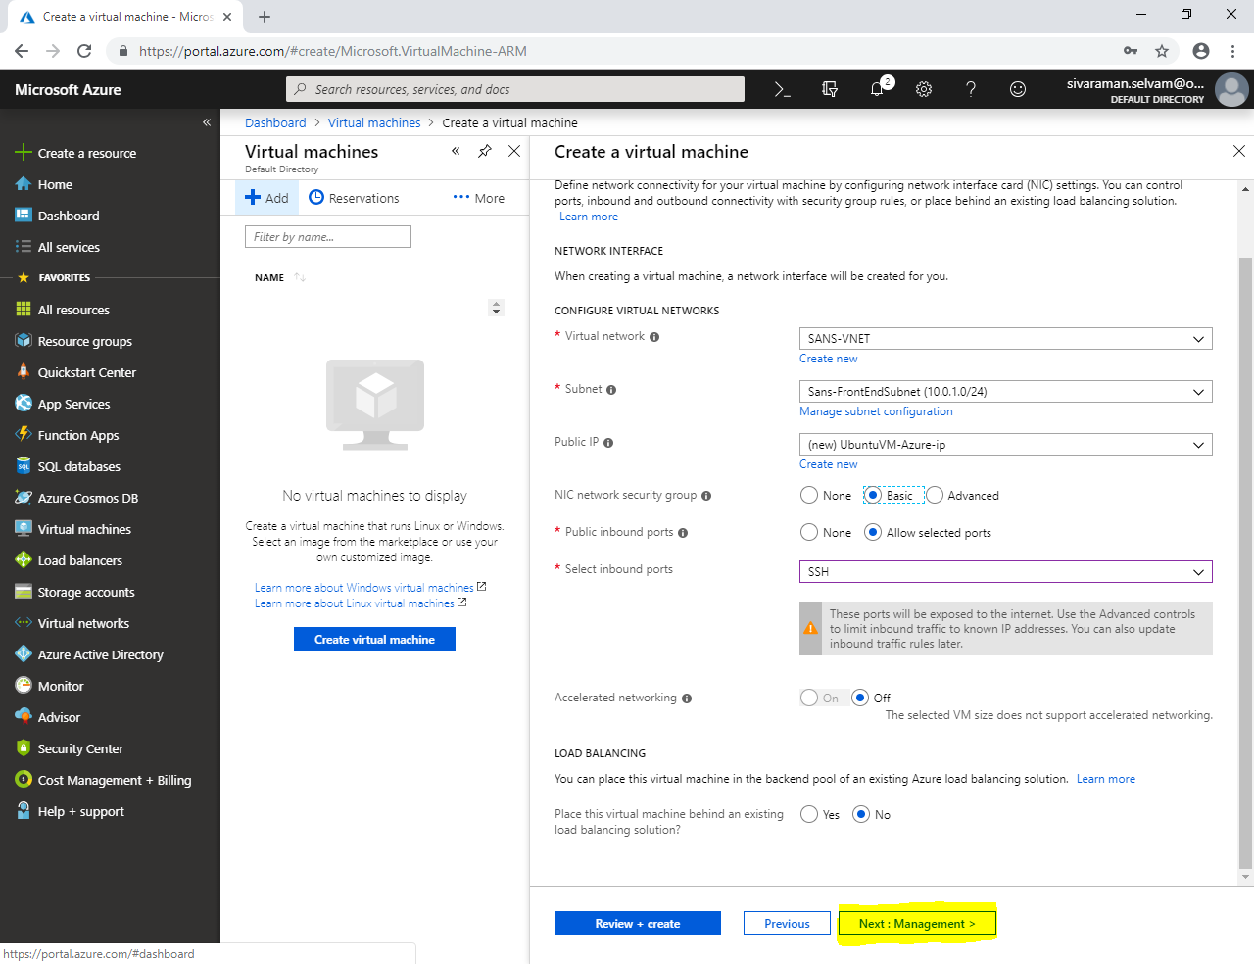

In **“Management”**.

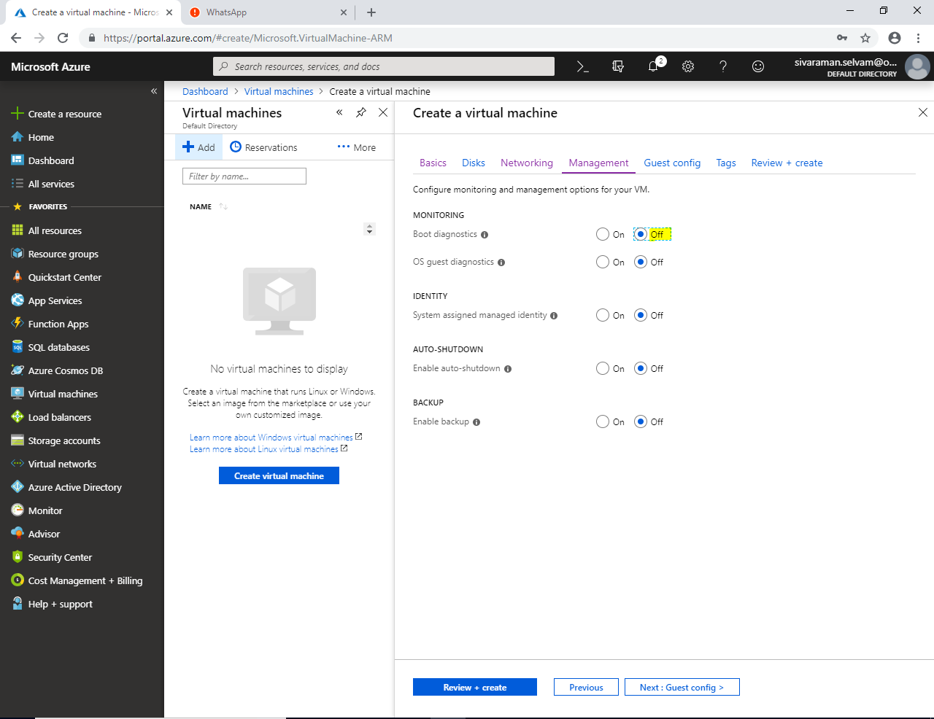

Click **“Next : Guest config >”**.

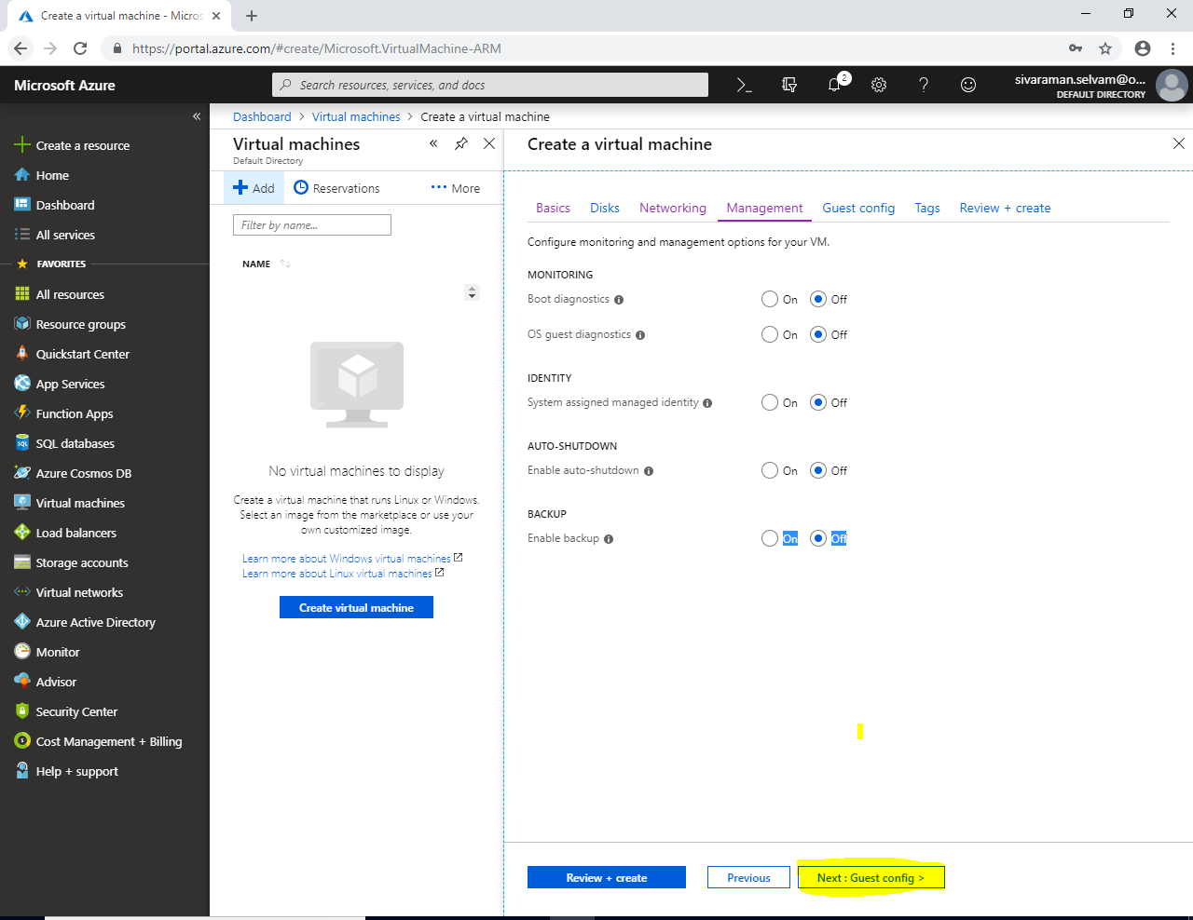

In **“Guest config”**.

Click **“Next : Tags >”**.

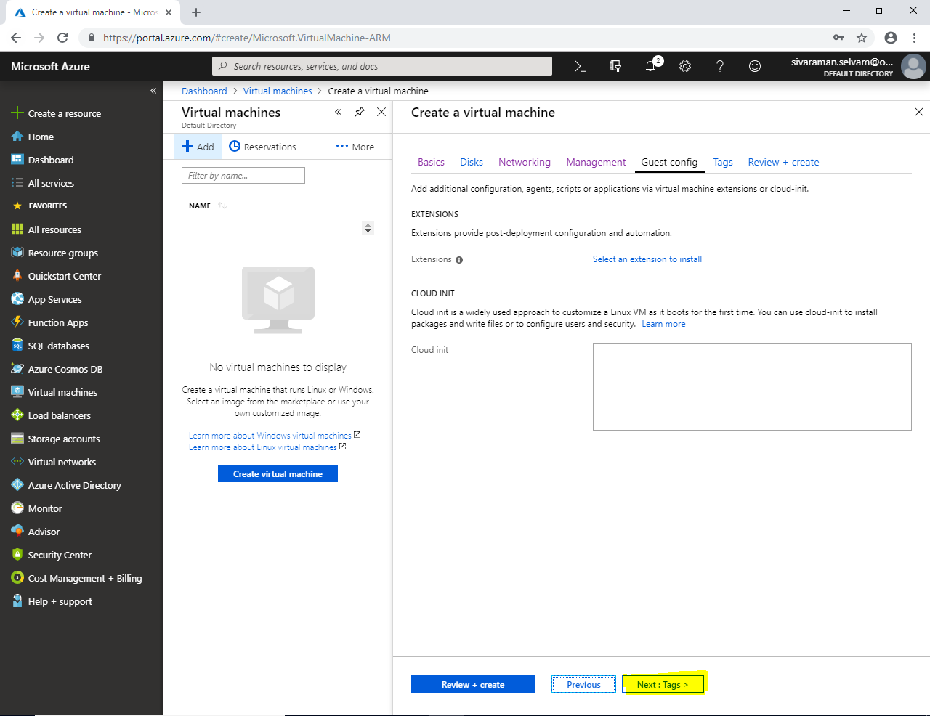

In **“Tags”**

Click **“Review + create”**.

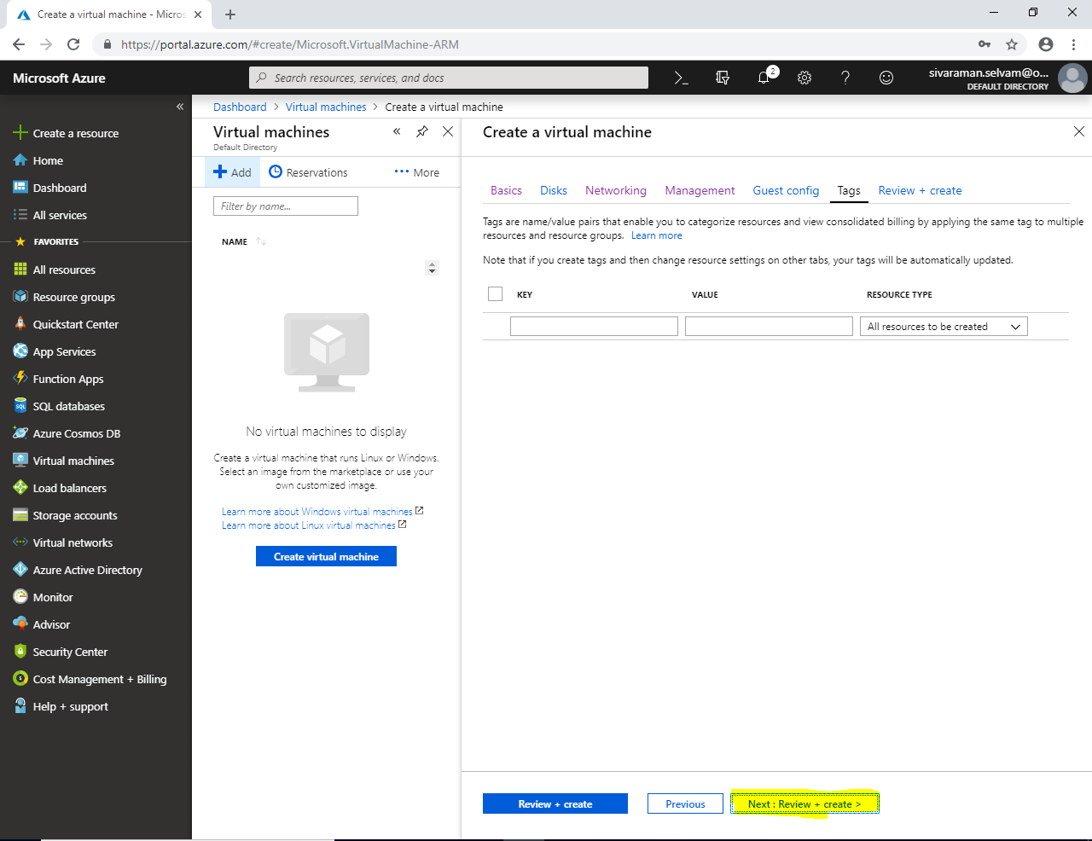

Click **“Create”**.

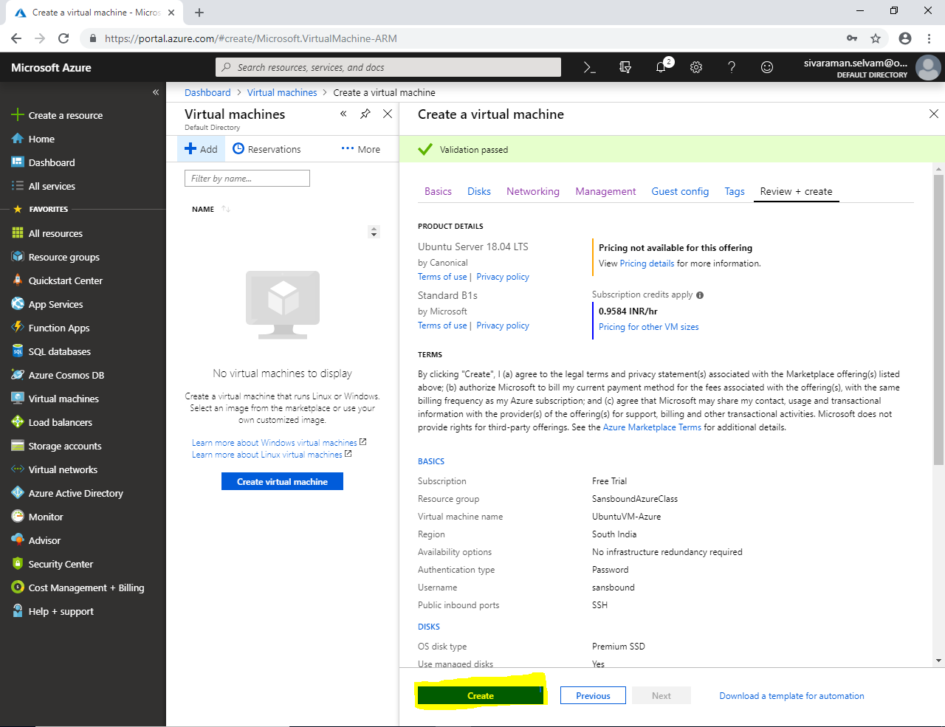

Your virtual machine has been created with **Managed disks with Premium SSD**.

Click on **“All resources”**.

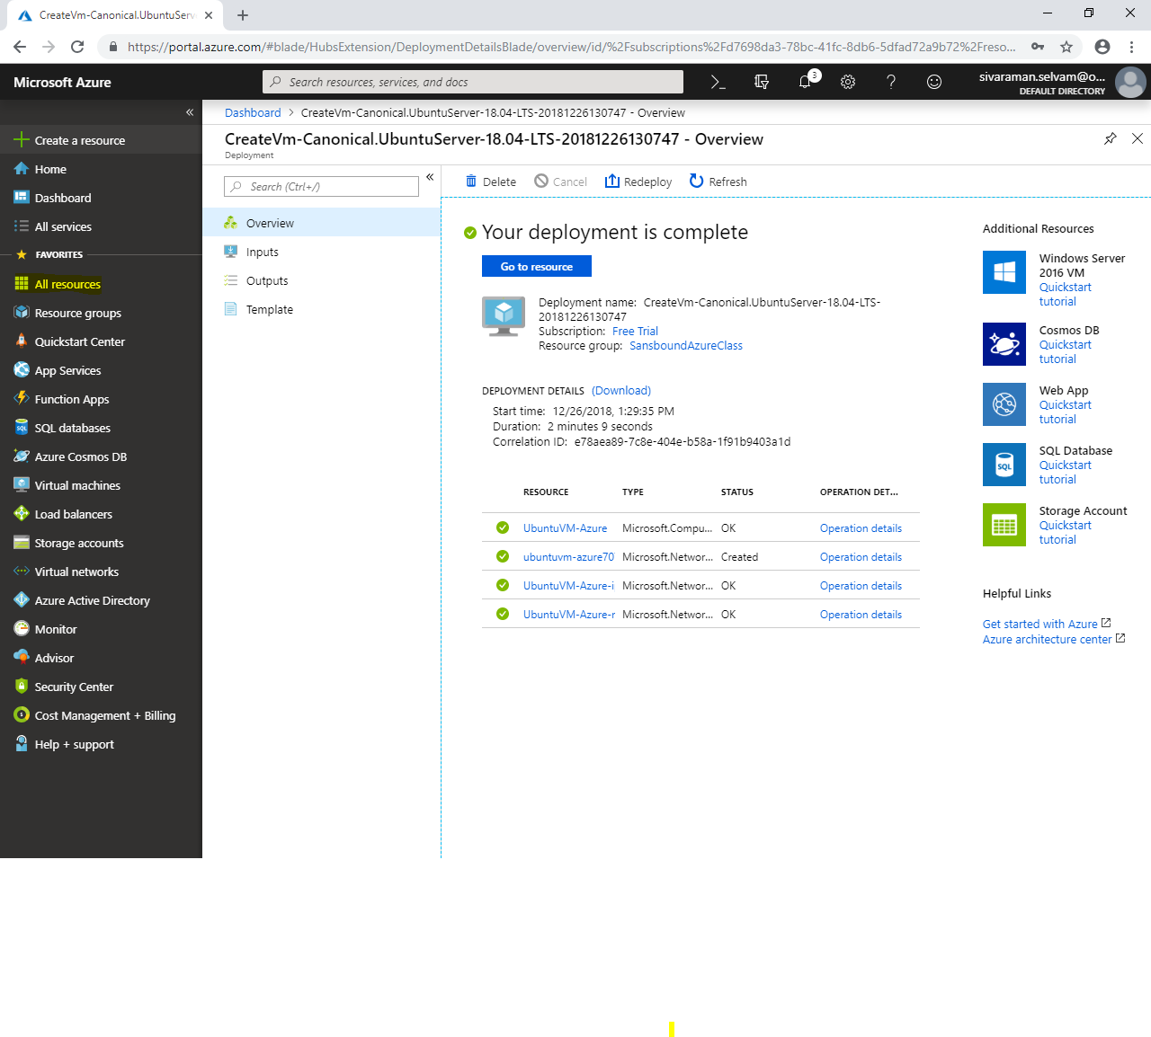

This is the managed disk which you have created.

Click “**Ubuntu-VM OS disk”.**

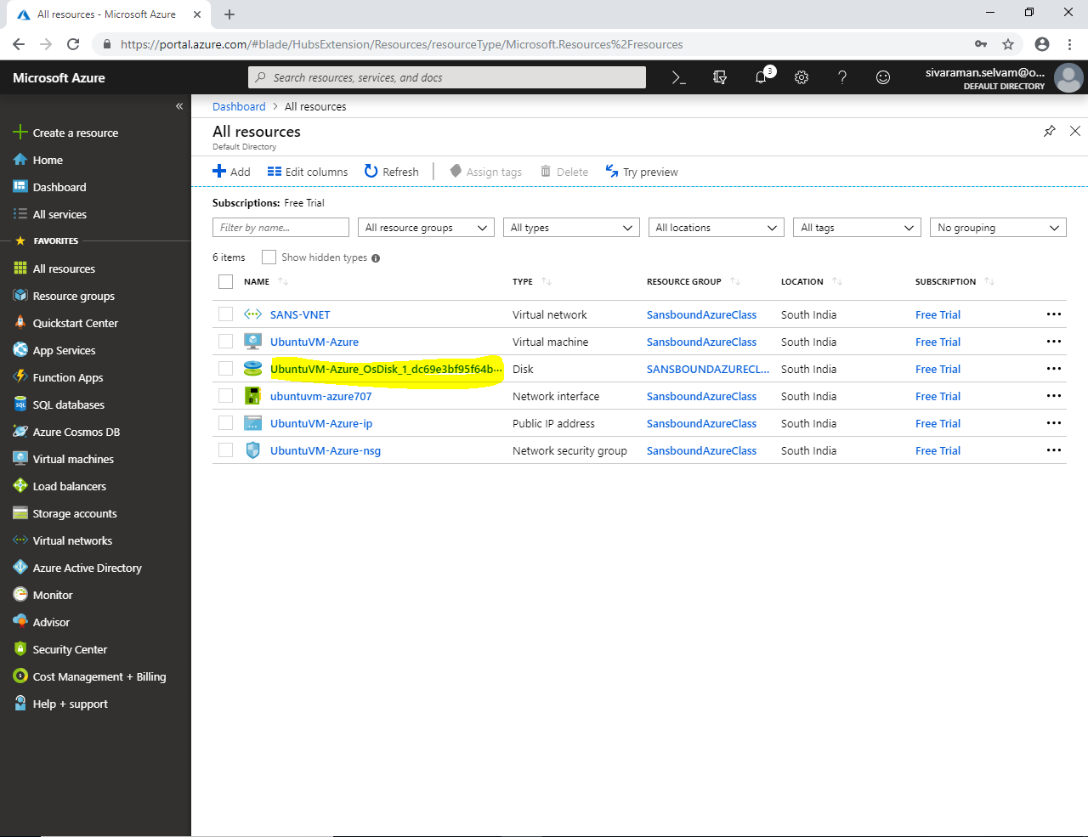

In **“Overview”** you are able to see the **“Disk configuration”**, **“Disk state”**, **“Owner VM”**, **“Location”** and **“Operating System”** details.

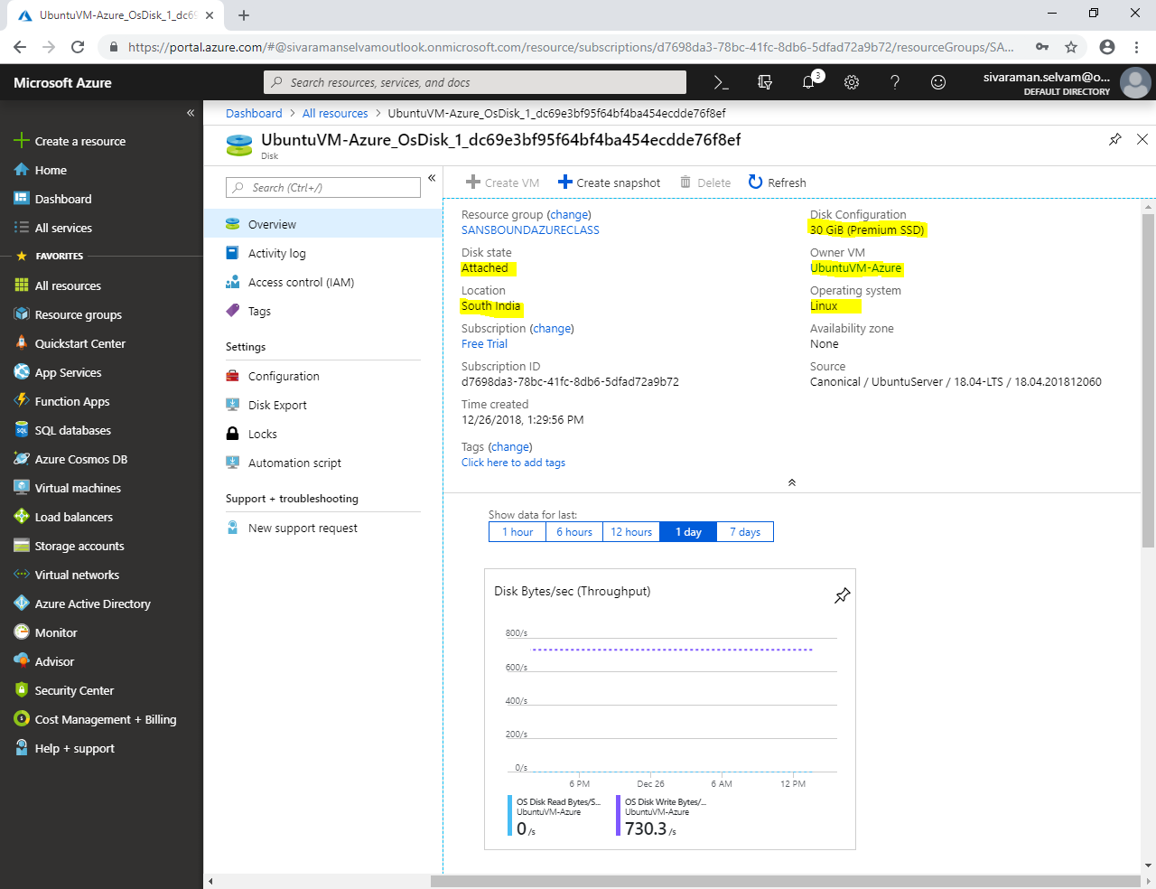

Click on **“Configuration”**.

Account Type **“Premium SSD”** is selected.

**Size of Disk(s) is 30 GiB**

**IOPS limit: 120**

**Throughput limit (MB/s): 25**

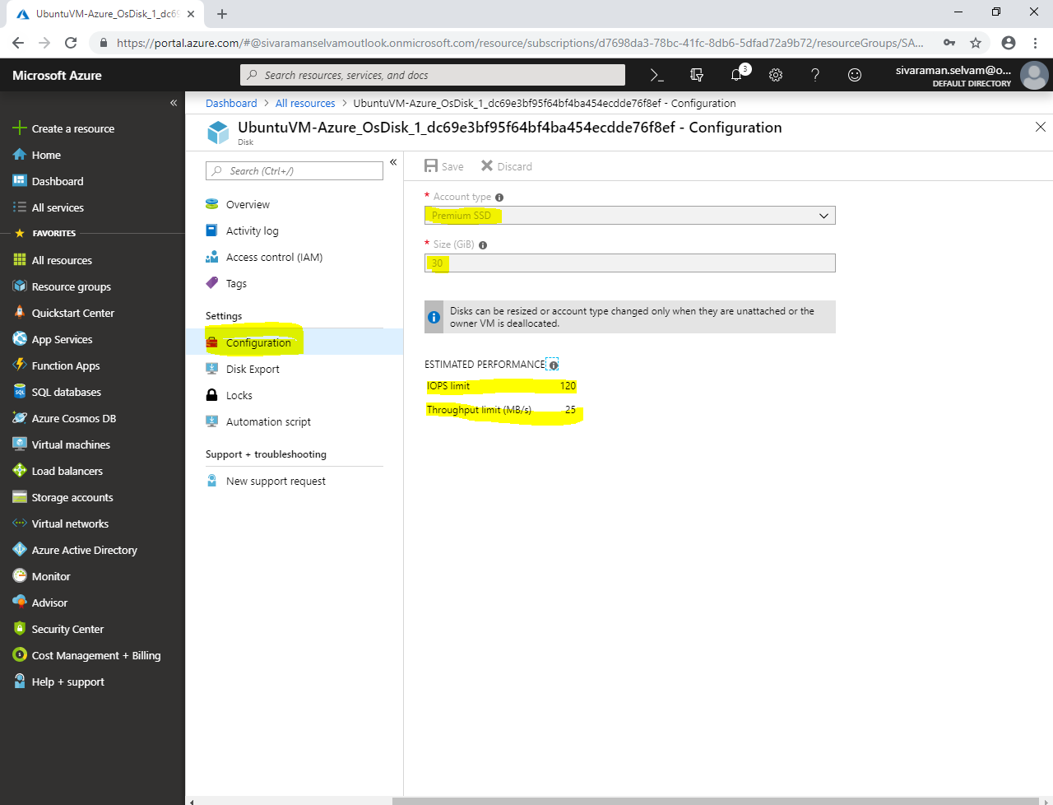

We will discuss feature of Managed disks briefly later.